A 2HOUR COBRA SUNDOWNER SELF‑DRIVE
Sunset Cruise in a Modern Classic Cobra
A sunset drive along Cape Town’s coastline is one of the most unforgettable ways to end the day — and nothing compares to experiencing it from behind the wheel of a Cobra.
Enjoy the freedom of an open‑top V8 as the Atlantic horizon turns gold.

Not sure where to go?
We’ll guide you in planning the perfect sunset route.
Activity Details:
Duration: 17h00 – 19h00
Experience Type: Self‑Drive
Vehicle: Official Backdraft Racing Cobra
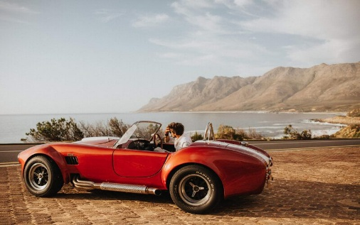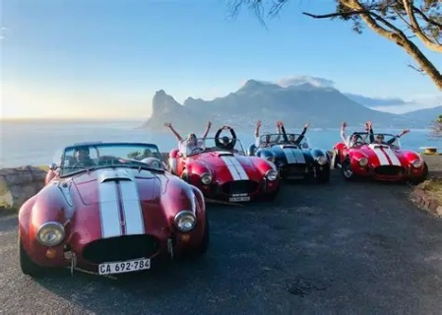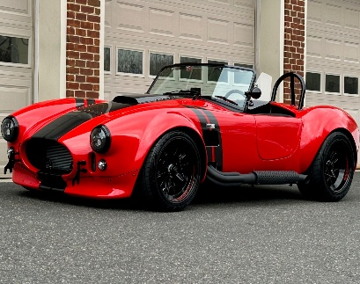
VEHICLE DETAILS
- Class: Modern Classic
- Doors: 2
- Seats: 2
- Fuel: Petrol
- Gearbox: Automatic
- Engine: V8
FACTORY BUILT | V8 | AUTOMATIC | POWER STEERING | MODERN BRAKES
ARRANGEMENTS
- When: Available all year
- Duration: 2 hours (17h00 – 19h00)
- Where: Foreshore, Cape Town, 8001
- Weather: Operates in safe weather conditions
- What to Wear: Comfortable clothing, closed shoes, warm jacket
- Things to Bring: Valid driver’s licence, credit card for deposit & toll roads

Passengers: One free passenger may join the drive
REQUIREMENTS
- Minimum Age: 23 years
- Qualification: Valid driver’s licence
Inclusions
- Pick up at hotel
- Drop off at site
- 35 km free mileage
- Pick up at site
- Drop off at hotel
Exclusions
- Fuel
- Additional kilometres

Chapman’s Peak Drive (Noordhoek ↔ Hout Bay) — excluded due to safety restrictions
SECURITY & LIABILITY HOLDING FEE
R15,000 (pre‑authorised on card)
A temporary holding fee covering insurance excess, vehicle damage, fines, recovery costs, or rental agreement breaches. Any unused amount is released after inspection and fine clearance.

Cash deposit: R20,000 or $1200
Cash deposits to be paid at the venue and may only be refunded from 08h30 the following day.
RATES
- Sunset Drive (2 hours): R2,900
- Additional Mileage: R20.00 per km
- Fuel: Must be replenished on return
- Extra Driver Fee: R500

(Sunset times vary seasonally.)
DEPARTURE & RETURN
- Departure: 17:00
- Return: 19:15

